**Project**: Autonomous navigator

**Presenters**: Naor Yadai (302568894)

Yosef Zohar (021512884)

**Project Advisor**: Dr. Boaz Ben Moshe

**Abstract**

Today there is a tendency to prefer unmanned aircraft (UAV) over manned aircraft.

UAV have many advantages:

1. **Safety** - no risk to human.
2. **Cost** - The cost of manned aircraft is low compared to regular plane.
3. **Performance** - UAV's small dimensions allow it to perform a variety of tasks and better quality than regular aircraft.

However UAV is operated by a person. Therefore, although the benefits listed above, there are some disadvantages using human operators:

1. **High budgets** - except for investment in the UAV itself, required an investment of high budgets to establish a supportive environment, such as simulators, wide technical team.
2. **Training** - it is necessary to train team to fly the UAV and will maintain competence
3. **Mistakes** - UAV can make a mistake during the operation relative to the discretion of the operator. On the other hand UAV that operated according to algorithm more accurate, a lower risk of error.

The purpose of this paper, the autonomous navigator, is to upgrade the system manned aircraft available today.

Targets are:

1. The UAV will operate autonomously without human intervention.
2. Autonomous navigator will help aircraft to perform the task while avoiding bumping into various obstacle.
3. This planned system adapted simplest UAV, which is easier and much smaller than the regular UAV (see accompanying diagram). So UAV will be able to make accurate and complete "quality jobs", which can not be perform by larger vessels.

According to a market survey that we conducted - most of the projects highlighted the subject image analysis and we are engaged in identifying obstacles with distance sensors and GPS revaluation.

The planned system includes four main components:

1. AR.Drone 2 - UAV

General information:

1. Highest speed: 11.11 m/s
2. Maximum height: 199.03m
3. Dimensions: 451x451x62mm
4. Weight: 380g
5. Distance sensors.
6. 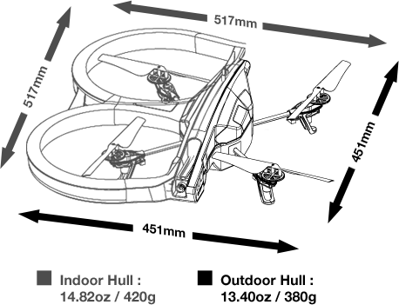GPS component.
7. Flight controller - receives the data from the sensors and GPS and giving instructions UAV flight.

